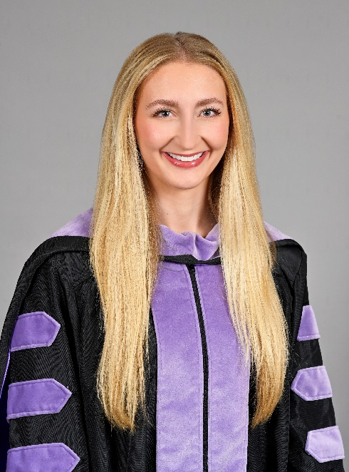

**Blakeley Michelle Bond**

9770 Highland Road

Baton Rouge, LA 70810

(308)293-7654

bondblakeley07@gmail.com

PERSONAL/PROFESSIONAL OBJECTIVE: **Dental Associate Position**

ACADEMIC BACKGROUND:

* **Louisiana State University Health Science Center School of Dentistry, New Orleans, LA** 
  + Doctor of Dental Surgery (DDS) (2019 – 2023)
  + 3.77 GPA
* **Baylor University, Waco, TX**
  + Bachelor of Science in Health Science Studies (2015 – 2019)
    - Minor in Biology and Chemistry
  + 3.74 GPA
* **Advanced Education in General Dentistry at the VA in Birmingham, AL**
  + Pursuing AEGD (2023-2024)
  + I will gain significant clinical experience by completing this program. I will be working with medically complex patients and will complete more advanced procedures such as implants, molar root canal treatment, surgical extractions, gingival grafts, etc. I will also learn IV sedation and advanced treatment planning to complement my dental school education.

HONORS AND AWARDS:

* **Honors In Teaching Program LSUSD** (2021 – 2023)
  + I completed the Honors in Teaching Program as LSUSD led by Dr. Andrieu. The purpose of this program was to learn educational tools from faculty to pass on to other students. I assisted Dr. Yu in the second-year fixed prosthodontics course and will complete a total of 175 hours of teaching. During this program, I gained knowledge on how to aid other students while enforcing the foundational pillars of dentistry.
* **LSU Board of Supervisors Scholarship Recipient** (2019 – 2023)
  + Louisiana State University Health Sciences Center School of Dentistry
    - New Orleans, LA
  + I have been selected for the past three years to be the recipient of the LSU Board of Supervisors Scholarship. This Scholarship has contributed to my tuition costs and assisted my journey to becoming a dentist. I am extremely grateful to have received this scholarship each year in dental school.
* **Alpha Lambda Delta Honors Society** (2015 – 2019)
  + Baylor University, Waco, TX
* **Dean’s Gold Scholarship** (2015 – 2019)
  + Baylor University, Waco TX
* **Dean’s List** (Fall 2016 – Fall 2017)
  + Baylor University, Waco, TX
* **Kappa Alpha Theta Honors** (Fall 2016)
  + Baylor University, Waco, TX
* **Kappa Alpha Theta Service Award** (Spring 2016)
  + Baylor University, Waco, TX

PROFESSIONAL MEMBERSHIPS AND

OFFICES HELD:

* **American Student Dental Association** (2019 – 2023)
  + Louisiana State University Health Sciences Center School of Dentistry
    - New Orleans, LA
  + Wellness Committee Member (2019 – 2023)
    - Assisted in organizing different wellness events for both physical and mental health. For example, yoga in the park, workout classes at local gyms, and study break sessions with animals from local shelters. Also the yearly Walk-A-Thon and events to support our military.
  + Attended ASDA District 5 Conference
    - During this conference I was able to attend numerous lectures on dental care, dental products, and the transition from school into the workforce. I also was able to network and ultimately further my knowledge of dentistry.
  + Philanthropy Committee Member (2022-2023)
    - Assisted in organizing and gathering items for various charitable donations throughout the year. Donations were gathered for numerous groups, including dental related charities.
* **American Dental Association** (2019 – Present)
  + Louisiana State University Health Sciences Center School of Dentistry
    - New Orleans, LA
* **Christian Medical and Dental Association** (2019 – Present)
  + Louisiana State University Health Sciences Center School of Dentistry
    - New Orleans, LA
* **Class Officer – PAL** (2021 – 2023)
  + Louisiana State University Health Sciences Center School of Dentistry
    - New Orleans, LA
  + I was elected by my classmates to be a member of PALs for my D3 and D4 year. In this position I am able to care for my classmates when they are enduring a difficult season in life. I have been able to give special gifts to others in our class as well as the assistants and instructors. I am also able to help counsel classmates if they are struggling and need support. In this position I have had the opportunity to send gifts of appreciation on behalf of my class to various staff at the school.
* **Academy of General Dentistry** (2019 – Present)
  + Louisiana State University Health Sciences Center School of Dentistry
    - New Orleans, LA

RESEARCH/PRESENTATIONS:

* **Selected for D1 Summer Research Program** (summer of 2020); Mentor: Dr. Fidel
  + Participated in continuing research regarding oral candidiasis infections. Completed numerous tests on mice and analyzed results.
* **LSUSD Department of Endodontics** (2021 – 2023); Mentor: Dr. Taylor; Extracted Tooth Library
  + Curated research project with Dr. Taylor and the Endodontics Department at LSU to create an Extracted Tooth Library. This library will house human and bovine teeth kept in analytical-grade conditions along with a digital catalog of 3D models. The library will allow for specific collections to be attained. With these collections, a range of analyses can be completed by students and faculty. Began drafting a publication on the formulation of the Extracted Tooth Library and the potential it holds to benefit dentistry. Will continue to finalize the draft in hopes of publication in the coming weeks.
* **Student Worker for Research with Dr. Taylor and Dr. Coreil**
  + While working with Dr. Taylor, I had the opportunity to complete projects with Dr. Coreil in the orthodontic department at LSUSD. I have assisted in assembling samples for tests completed through a private company, ORMCO. Publication is currently pending and further tests will be assembled and completed to contribute to findings.

VOLUNTEER SERVICE:

* **Grace Food Kitchen** (2021 – 2022)
  + Louisiana State University Health Sciences Center School of Dentistry
    - New Orleans, LA
  + I have had the opportunity to serve at Grace Food Kitchen. I have enjoyed serving those in my own community especially when enduring a challenging season in life.
* **Give Kids a Smile Day** (2021 postponed)
  + Louisiana State University Health Sciences Center School of Dentistry
    - New Orleans, LA
* **Adopt an Angel** (2021 - 2023)
  + Louisiana State University Health Sciences Center School of Dentistry
    - New Orleans, LA

EXTERNSHIPS:

* **Texas A&M College of Dentistry Postgraduate Endodontics Department** (November 2022)
* **Dental College of Georgia Postgraduate Endodontics Department** (February 2023)

WORK/SHADOWING EXPERIENCE:

* **Pediatric Dental Specialists of Baton Rouge** (2017 – 2019)
* **Root Canal Specialists of Baton Rouge** (2019 – 2023)
  + I have had the opportunity to shadow Dr. Mike Bond and Dr. Gwen Corbett during my time in dental school. I have observed the completion of numerous endodontic and surgical procedures.
* **Accardo Endodontics** (2023)
  + I have had the opportunity to shadow and observe Dr. Chelsea Accardo. I have observed Dr. Accardo complete consults, treatment, and surgery.
* **Endodontic Department as LSUSD** (2021 – 2023)
  + During my time in dental school, I have been able to assist postgraduate residents in the endodontics department. I have also attended case reviews where the residents discuss difficult cases they have encountered each week.

EXTRACURRICULAR ACTIVITIES:

* Member of Celebration Church (2019 – 2023)
* Member of Lakeshore Church Dental Life Group (2021 – 2023)
* Member of Vizsla’s of New Orleans (2021 – present)
* Avid exercise enthusiast and member of Premier Fitness (2021 – present)